**Software Setup Instruction**

# I.Website Environment:

|  |  |  |  |
| --- | --- | --- | --- |
| **Web side** | | | |
| **Web application** | **Software** | | **Version** |
| OS | Windows | 7 (64-bit) |
| IDE | Myeclipse | 10 |
| Server | Tomcat | 7 |
| Java VM | JDK | 1.6 |
| Web browser | Chrome | 73.0.3683.103  (Official Build) (64-bit) |
|  |  |  |  |
| **DB Side** | | | |
| **Database** | **Software** | | **Version** |
| Virtual Machine | Vmware workstation | 8 (64-bit) |
| Database | Oracle | 10 |

# II.How to setup website environment:

## 1.Setup JDK 1.6

1) Download JDK 1.6 from <https://www.oracle.com/technetwork/java/javase/downloads/java-archive-downloads-javase6-419409.html>

2) Configure System Environment variables

**JAVA_HOME** C:\Program Files (x86)\Java\jdk1.6.0_45

**CLASS_PATH** .;%java_home%\lib\dt.jar;%java_home%\lib\tools.jar;%java_home%\lib\javax.mail.jar

**PATH**  C:\Program Files (x86)\Java\jdk1.6.0_45\bin;C:\Program Files (x86)\Java\jre6\bin;

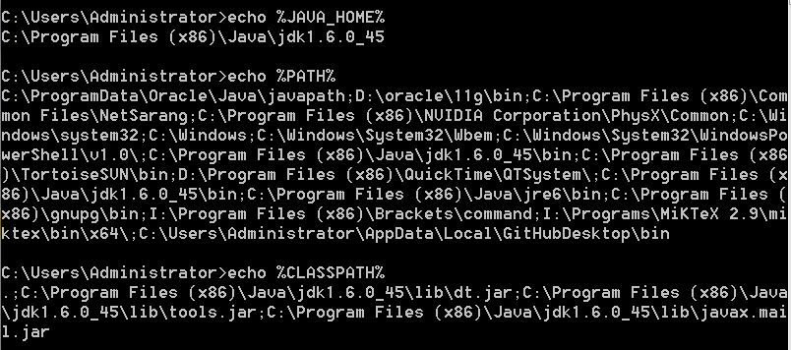

## 2. Setup Tomcat 7.0

1) Configure System Environment variables



## 3. Setup Myeclipse 10



### 3.1 Import source code

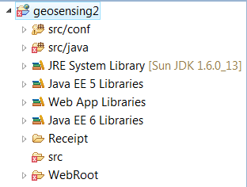

### 3.2 Configuration of Tomcat Server

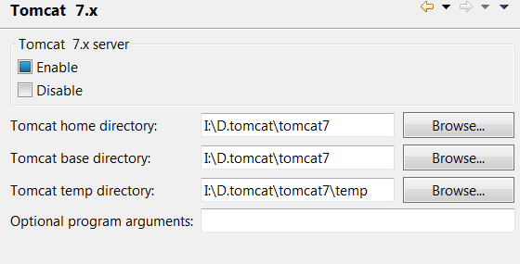

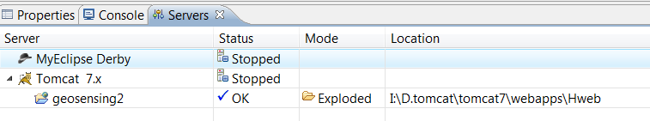

### 3.3 Configuration of Java Libraries

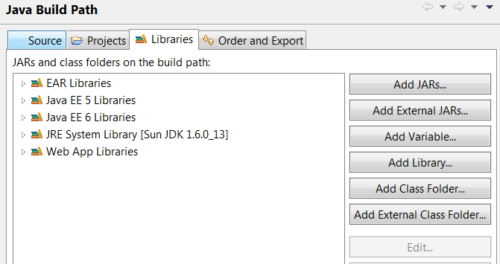

## 4. Setup VMware workstation 8 with Linux Operating System

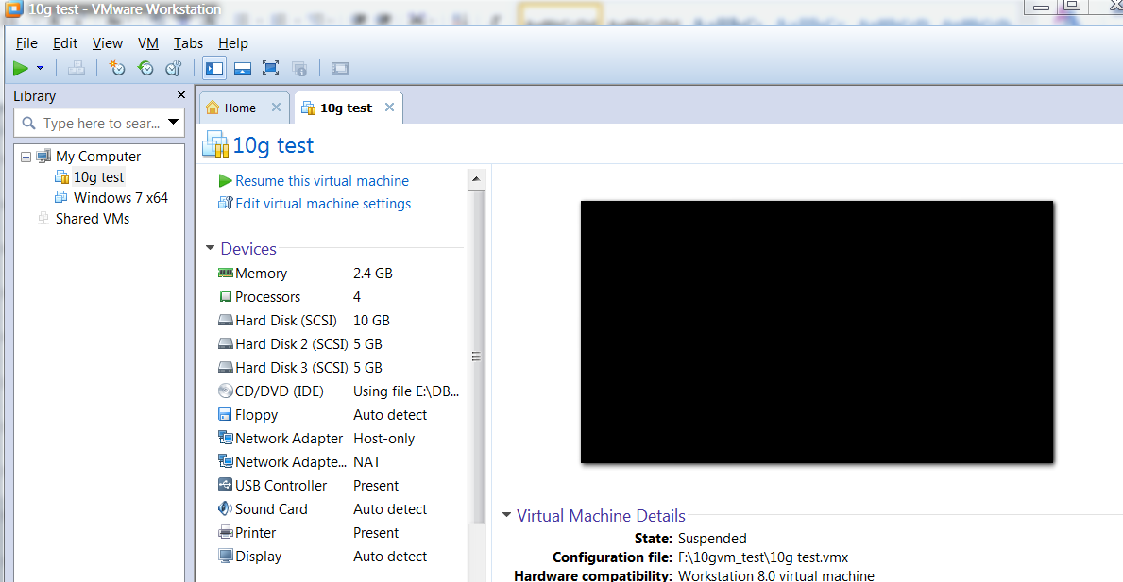



## 5. Setup Oracle 10.0

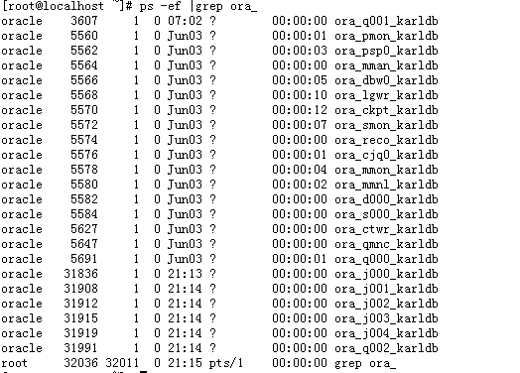

# III. Connection between Windows 7 and VMware Linux

## Configuration of Oracle client

Edit D:\oracle\11g\NETWORK\ADMIN\tnsnames.ora

sqli =

(DESCRIPTION =

(ADDRESS = (PROTOCOL = TCP)(HOST = 192.168.109.110)(PORT = 1521))

(CONNECT_DATA =

(SERVER = DEDICATED)

(SERVICE_NAME = karldb)

)

)

Note : 192.168.109.110 is DB server IP , karldb is Database SID

## 2. Connect through Windows 7 to VMware Linux

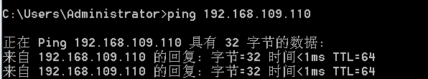

## 3. Connect through Website application to Database

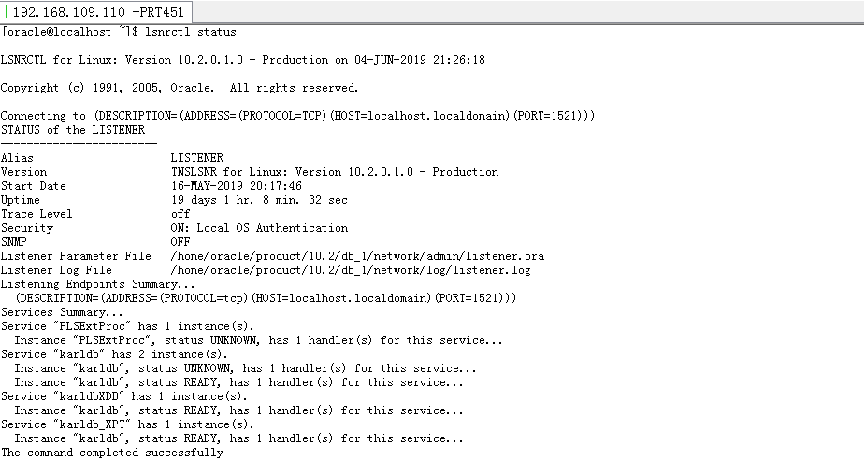

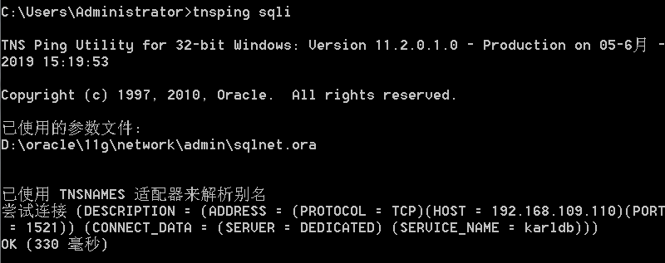

# IV. Create database objects

*--T_parking_slots*

*drop table karl.T_parking_slots;*

*create table karl.T_parking_slots (*

*parking_id varchar2 (10) not null,*

*Slot_id varchar2 (10) not null,*

*parking_station varchar2 (30),*

*charging_from varchar2 (8) , --'08:00 AM'*

*charging_to varchar2 (8) , --'16:00 PM'*

*location_lat varchar2 (30),*

*location_lng varchar2 (30),*

*status varchar2 (15),*

*price number(10)*

*);*

*create unique index karl.i_parking_slots_p_s on karl.T_parking_slots(parking_id,slot_Id) ;*

*alter table karl.T_parking_slots add constraint pk_parking_slots primary key (parking_id,slot_Id) using index;*

*--insert slots data*

*set define off;*

*insert into karl.T_parking_slots values*

*('A','01','Purple A','08:00','16:00','-12.371799145462651','130.86761444807055','Available',3);*

*insert into karl.T_parking_slots values*

*('A','02','Purple A','08:00','16:00','-12.371799145462651','130.86761444807055','Available',3);*

*insert into karl.T_parking_slots values*

*('A','03','Purple A','08:00','16:00','-12.371799145462651','130.86761444807055','Available',3);*

*insert into karl.T_parking_slots values*

*('A','04','Purple A','08:00','16:00','-12.371799145462651','130.86761444807055','Available',3);*

*insert into karl.T_parking_slots values*

*('A','05','Purple A','08:00','16:00','-12.371799145462651','130.86761444807055','Available',3);*

*insert into karl.T_parking_slots values*

*('A','06','Purple A','08:00','16:00','-12.371799145462651','130.86761444807055','Available',3);*

*--insert into karl.T_parking_slots values*

*('A','07','Purple A','08:00','16:00','-12.371799145462651','130.86761444807055','Available',3);*

*--insert into karl.T_parking_slots values*

*('A','08','Purple A','08:00','16:00','-12.371799145462651','130.86761444807055','Available',3);*

*commit;*

*--T_mapping_zone*

*drop table karl.T_mapping_zone;*

*create table karl.T_mapping_zone (*

*parking_id varchar2 (10),*

*parking_zone_color varchar2 (30),*

*location_lat varchar2 (30),*

*location_lng varchar2 (30)*

*);*

*--T_order_details*

*drop table karl.T_order_details;*

*create table karl.T_order_details (*

*order_id varchar2 (10) not null,*

*parking_id varchar2 (10),*

*slot_id varchar2 (10),*

*start_time date ,*

*end_time date ,*

*recepit_no varchar2 (30), --start with 5 bit number*

*order_status varchar2 (10), --0' - unpaid '1'- paid*

*Amount number (10),*

*email varchar2 (30),*

*Send_email_status varchar2(10) --'yes' --null by default*

*);*

*create unique index karl.pk_order_details on karl.T_order_details(order_id) ;*

*alter table karl.T_order_details add constraint pk_order_details primary key (order_id) using index;*

*--create*

*CREATE SEQUENCE karl.Q_order_details*

*MINVALUE 1*

*NOMAXVALUE*

*INCREMENT BY 1*

*START WITH 1 cache 20;*

*CREATE SEQUENCE karl.Q_order_details_recepit*

*MINVALUE 1*

*NOMAXVALUE*

*INCREMENT BY 1*

*START WITH 10000001 cache 20;*

*--insert SQL*

*--INSERT INTO KARL.T_ORDER_DETAILS VALUES (KARL.Q_ORDER_DETAILS.NEXTVAL,?,?,SYSDATE,SYSDATE+120/1440,KARL.Q_ORDER_DETAILS_RECEPIT.NEXTVAL,'PAID',?,?)*

*--calculate amout of hour booking that needs to be charged, defaut booking time is 2 hours*

*--input value(sysdate) = T_order_details.start_time*

*--SELECT (CASE WHEN to_char(sysdate,'HH24:mi') > '06:00' and to_char(sysdate,'HH24:mi') < '07:00'*

*-- THEN 1*

*-- WHEN to_char(sysdate,'HH24:mi') >= '07:00' and to_char(sysdate,'HH24:mi') <= '15:00'*

*-- THEN 2*

*-- WHEN to_char(sysdate,'HH24:mi') > '15:00' and to_char(sysdate,'HH24:mi') < '16:00'*

*-- THEN 1*

*-- ELSE 0 END) * 3 'AMOUT' ,sysdate*

*--from dual;*

*--T_user_info*

*drop table karl.T_user_info;*

*create table karl.T_user_info (*

*user_id varchar2 (10) not null,*

*firstname varchar2 (30) not null,*

*lastname varchar2 (30) not null,*

*email varchar2 (30) not null,*

*password varchar2 (30) not null,*

*phone_number number (10) ,--not null,*

*cc_number number (6 ) ,*

*cc_expiration date ,*

*cc_cvv number (3 ) ,*

*cc_name varchar2(30)*

*);*

*create unique index karl.pk_user_info on karl.T_user_info(user_id) ;*

*alter table karl.T_user_info add constraint pk_user_info primary key (user_id) using index;*

*create index karl.i_user_info_name on karl.t_user_info(firstname,lastname);*

*create unique index karl.i_user_info_email on karl.t_user_info(email);*

*create unique index karl.i_user_info_phone on karl.t_user_info(phone_number);*

*create unique index karl.i_user_info_cc_no on karl.t_user_info(cc_number);*

*--create*

*CREATE SEQUENCE karl.Q_user_info*

*MINVALUE 1*

*NOMAXVALUE*

*INCREMENT BY 1*

*START WITH 1 cache 20;*

# V. Start-up Website application.

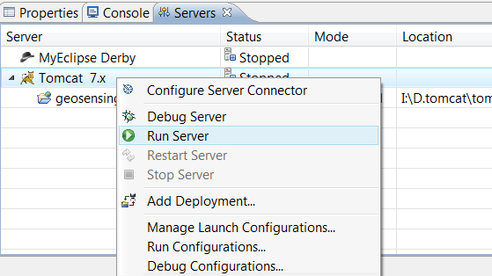

Access URL : <http://localhost:8080/Hweb/index.jsp>

